PRODUCT TEMPERATURE RESPONSE OF A LOCALLY DEVELOPED EXTRUDER TO DIFFERENT EXTRUSION CONDITIONS
Please check the proofs,make corrections and return to us. If possible extend the help of US$ 200 towards the printing etc, we shall send you 25 reprints& journal copy by regd. Air mail

Folasayo T. Fayose, Ph.D, COREN Regd.
Department of Agricultural Engineering Technology
Rufus Giwa Polytechnic, 234-034, Owo – Nigeria
fayosesayo@yahoo.com
+2348035862761

ABSTRACT

In this study, the product temperature response of a single screw extruder developed locally was investigated for the extrusion process of the flour and starch of maize and cassava which are grown in Nigeria in large quantity but yet underutilized. These were compared with wheat flour which is commonly used for the production of alimentary pastes in a factorial experiment in completely randomized design A maximum temperature of 150ºC per 30 minutes was attained through viscous dissipation and up to a moisture loss of 55% w.b. Also, product temperature is strongly related to the starch type and the extrusion process parameters under study. Product temperature decreased with increasing moisture content. The highest values of product temperature were demonstrated by maize starch and cassava flour extrudates while the lowest values were observed on maize flour and wheat flour extrudates. The equations relating the various dependent and independent variables were established to predict the performance of the machine.

Key words: Extrusion, Product temperature, Cassava starch, flour, Maize, Wheat.

- INTRODUCTION

Cassava (Manihot esculenta, Crantz) and maize (Zea mays) are important starch-rich crops grown in many parts of the world that contributes to economic development and food security, most especially in low income food deficient countries because of their inherent characteristics. Cassava tolerates environmental stresses such as short periods of drought, strong and desiccating winds and low soil fertility (Balogun, 2000). Its cultivation does not involve complicated technology, high labour or other inputs. Maize, another popular staple food plays an important role in the diet of millions of people because of dry matter per hectare, its ease of cultivation, versatile food uses and storage characteristics (Asiedu, 1992). Nigeria is rated to be one of the largest producers of cassava and maize, producing annually more than 80 million and 7019 metric tonnes respectively (Adetunji, 2004; CBN, 2003). ). However, a high percentage of the crop is lost because of inadequate alternative processing options. Wheat flour has been widely used in the extrusion industry and the effects of process variables on wheat extrudate properties have been studied (Frame, 1994). Meanwhile, it is obvious that cassava as a crop is not popular for the production of extruded foods. Maize is one of the most common types of starch used for extrusion on which a lot of research work has been done but not in the developing nations where it is grown in large quantity. Extrusion is a food processing operation that can increase the usefulness of starchy crops by producing a range of products with different shapes, nutrients, texture, colours, sizes, flavour etc, thereby increasing the varieties of food products in the diet.
Product temperature is one of the dynamically controlled variables usually taken to reflect and predict product quantity in the food extrusion (Olkku 1980). As a system parameter it can be used to connect extrusion cooking conditions such as screw speed, moisture content, screw configuration e.t.c and product conversion (Water Absorption index, Water Solubility Index) and thus to optimize and scale up the process appropriately (Bouvier, 2001).

It is necessary to determine product temperature in preliminary studies of extruders so as to understand and know the temperature profile under any condition and to be able to control it effectively for any particular application. Also, long term trends such as wear can be more closely monitored by observing extruder temperature data, thus providing management data. The present study was undertaken to determine the effects of different extrusion conditions (screw speed, moisture content of feed, and extrusion time and types of crop) on product temperature of a locally developed extruder.

2.0 MATERIALS AND METHODS

Sample preparation
Samples of flour and starch of the two crops under study were sourced and prepared from the same varieties grown under the same cultivation practices to give room for basis of comparison of results. Cassava tubers (Manihot esculenta Crantz) TMS 30572, were sourced from experimental plots at the Federal College of Agriculture, Akure and processed into flour and starch respectively according to International Starch Institute standards(2005). The materials were passed through a 300um sieve separately and the proximate analysis and moisture contents of samples were determined as described by AOAC (1995) approved method. White maize, EV8363-SR QPM (breeder seed) was sourced from the International Institute of Tropical Agriculture (IITA), Ibadan and processed into flour and starch respectively as described by Akanbi et al (2003). Hard durum wheat flour (Triticum aestirum) was purchased from Akure main market.

Extrusion
The extruder used in this study is the dry type. It is made up of three (3) main units namely the feeding unit, the compression and melting unit and the die unit all fabricated using locally available materials. The feeding unit and the compression/melting unit are operated by one electric motor through a gear reducer and belt and pulley transmission system. As a test rig, allowance was given for varying the screw configuration, feed rate, screw speed, die configuration and nozzle. Speed regulation is done by varying the pulley ratios. All parts through which the feed material will pass were made of stainless steel to prevent food contamination and to withstand frictional wear. Figure 1 shows the isometric drawing of the extruder.

The screw is of single flight, increasing diameter and tapering/decreasing pitch with a compression ratio of 4.5:1. The diameter of the final portion of the screw is reduced to a cone. This aid in pressure built up, easy conveyance of materials through the die and in reducing wear rate. The length to diameter ratio is 12:1. An electric motor drives the screw through a gear reducer, and the backward thrust of the screw is absorbed by a thrust bearing. The barrel and the screw/die configuration is typical of alimentary food production equipment. The extrudates were extruded as ribbons to be cut with a rotary cutter.

Experimental procedure
Samples were fed into the extruder at a feed rate 10Kg/h. The feeding section of the extruder was maintained at room temperature. The extruder was operated for 30 minutes for each set of condition. Steady state extrusion conditions is assumed to have been reached where there is no visible drifts in products temperature and torques required to turn the screw and by a steady extrusion rate. Temperature, both of the barrel and product were varied by continuous running of the machine, thereby building up the temperature. A major reason why heat is better generated through viscous dissipation than that added or removed through the barrel walls is that heat generated by drive unit (through viscous dissipation) is more dominant and cost efficient (Liang et al., 2002).

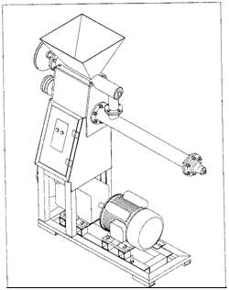
A
B
C
D
E
F
G
I

H

Figure 1: Isometric views of the extruder

Since barrel temperature varies with duration of operation, duration of operation was observed as an independent variable. Temperature was controlled by removing and dipping the barrel and screw in a bath of cold water each time the extruder is to be fed with samples.

This experiment was conducted using a factorial design comprising of five levels of product classification, three levels of initial moisture content, three levels of screw speed and five levels of duration of operation of machine. The four independent variable levels were pre-selected based on the results of preliminary tests. Each treatment was replicated thrice. One way ANOVA, least significant follow up tests, and stepwise multiple regression analysis were carried out using Statistical Package for Social Scientists (SPSS 13.0) software while response surface regression and correlation analysis were carried out using the data analyst and response surface regression procedures of Statistical Analysis System (SAS) software v.9.R₁ (2003). Microsoft excel © 2007 was used for plotting graphs. Regression analyses were employed to fit the experimental data to second- order polynomials.
LEGEND
A- Hopper
B- Feeding Conveyor
C- Extruder worm
D- Die Unit
E- Power train
F- Conveyor pulley
G- Extruder pulley
H- Extruder Housing
I- Control switch

Data collection and analysis
Official methods of the Association of official Analytical chemists (1995) were used for moisture, ash, protein, fat and crude fibre. The carbohydrate content was determined by difference. Moisture contents of native starch samples and their extrudates were determined on a dry basis by an oven method using the AOAC (1995) method. Barrel and product temperatures were determined as described by Chessari and Sellahewa (2001) with K type copper- constantan thermocouple inserted into the barrel immediately before entry of the mass into the die and with Portec CAI 001 thermometer probe (Portec instrumental, Milton Keynes, UK) inserted into the melt immediately before passage of the mass out of the die. The result was read from a read out digital meter.

3.0 RESULT AND DISCUSSION
The Proximate composition of all the materials under study is presented in Table 1. One very important observation made is that the protein content of this variety of cassava flour is very high when compared with results from previous studies (Badrie and Mellowes, 1991). This result shows that the protein content of TMS 30572 variety of cassava is high when compared with other varieties used in previous studies. Efforts to improve cassava have being focused on increasing yield, dry matter content, nutritional and protein content as a means to contribute to a sustainable and cost effective solution to malnutrition (Dixon et al., 2007).

Table 1: Proximate compositions of samples.
Mc Protein Fat Ash Fibre Carbohydrate
cs 1.47 0.31 1.50 0.20 0.12 96.40
cf 1.90 7.36 1.4 1.62 0.24 87.48
ms 2.45 0.86 2.32 0.40 0.15 93.82
mf 1.30 3.95 2.43 0.80 0.36 91.16
wf 9.65 13.20 1.50 0.45 2.17 3.10
--------------------------------------------------------------------

Figures 2 - 4 show the effect of extrusion variables (initial moisture content, duration of operation and screw speed) on product temperature. The graph shows that product temperature varies directly with duration of operation. Product temperature increased with increase in duration of operation. Also, product temperature increased from 100 to 150 rpm and then decreased at 200 rpm. Extruder’s performance improved from 100 to 150 rpm but at 200 rpm there was a change over in the performance of the extruder. The reduction in temperature is due to the decrease of mean residence time due to increase in screw speed. The shorter the time the feed material stays in the extruder, the less energy it receives from the process at constant feed rate. This was what brought about Specific feeding load (SFL) in previous studies (Frame, 2004; Lo et al., 1998).

Highest temperature was observed for maize starch (ms) while the minimum temperature was that of maize flour (mf). A maximum temperature of 150⁰C was attained in 30 minute through viscous dissipation at 150 rpm and 30% moisture content. The product temperature at 30 % moisture content was higher than at 25 and 40% moisture content. Steady state condition was attained within 15 minutes for samples 30% moisture content while it took longer time for samples with 25% and 30% moisture contents.

This result agrees with those of Fletcher “et al” (1985) who investigated the extrusion cooking of maize flour for typical operating conditions: Throughput = 30 kg/h, screw speed = 300 rpm and 400 rpm, and moisture content = 25 to 83% (wet basis). The product temperature attained to was between 75 and 150ºC. However, for cassava flour (cf) the product temperature decreased with increase in moisture content from 25 to 40%. The difference observed between cassava starch and cassava flour might be due to the differences in their carbohydrate and protein contents. For example, the increased protein content of cassava flour when compared to that of cassava starch (cs) might be responsible for the difference in their product temperature.

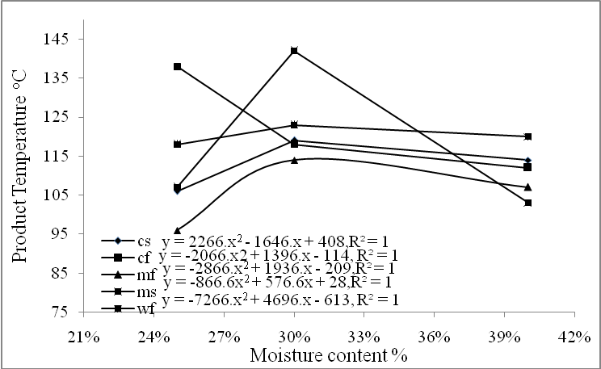

Figure 2: Variation of product temperature with initial moisture content at
extrusion time 30 minutes and screw speed 100 rpm.
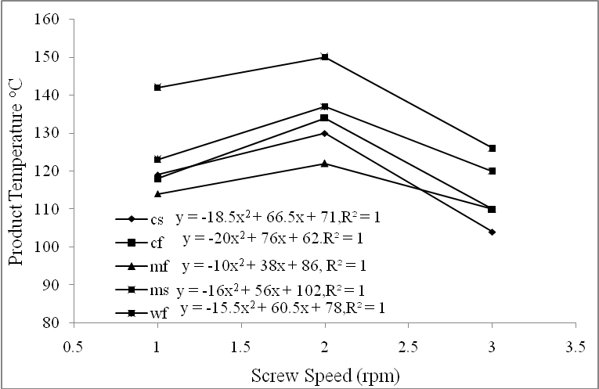
Figure 3: Variation of product temperature with screw speed at 30 minutes
extrusion time and 30% initial moisture content.

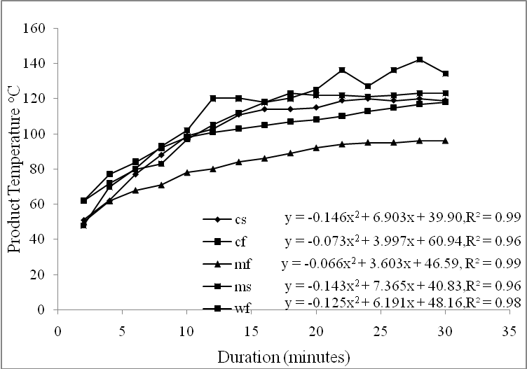

Figure 4: Variation of product temperature of products with duration of operation at
100 rpm screw speed and 30% initial moisture content.
The result of the statistical analysis showing the order of importance of variables is presented in Table 2. The interaction term improved the model. Duration of sampling has the highest contribution, 62.8%, to R² of Product temperature. The interaction term of screw speed and moisture content (sm) improved the model R² by 2.5%, The Variance Inflation Factor (VIF) value for all parameter estimates were 1.0. Therefore, it can be concluded that multicollinearity is not a problem in this case. For corn meal, dough temperature studied at various extrusion conditions (Chang and Halek, 1991) increased with increased barrel wall temperature zone 5, the most important factor that accounted for nearly 0.96 of the total R². Food moisture or screw speed showed a slight effect. Also, food moisture and screw speed did not represent high R² but are yet significant. It was speculated that since increase in screw speed reduced residence time, degree of fill and filled length, increases in viscous heating would be balanced by reduced barrel heat transfer. This was confirmed by the fact that dough temperature for screw speed 200 rpm only differed from that for 100 rpm slightly. For wheat starch, Van Zuilichem and Stolp (1987) reported a similar case that a temperature of 95ºC was attained in 44 minutes with an extruder of the following configuration: screw L/D: 1/12, compression ratio: 2.94 screw speed: 100 rpm and moisture content: 15.9 - 16.7%. The viscosity attained to within the period was 18 x 102 BU. However when the time of operation was extended beyond one hour to one hundred and three minutes the temperature decreased. Also, a decrease in die diameter as well as in the moisture content led to an increase in Product temperature for wheat starch (O’ Connor, 1987).

Table 2: Stepwise Regression of Product temperature for all Product Classification

Models | Coefficients |  | T-test | Prob | Adjusted R² | F value | Prob | VIF
1 | Bo | 63.785 | 57.440 | .000 | .627 | 1158.038 | .000 | 1.000
1 | Dt | 2.081 | 34.030 | .000
2 | Bo  Dt  sm | 73.537  2.082  -.002 | 41.755  35.214  -6.986 | .000  .000  .000 | .652 | 643.770 | .000 | 1.000  1.000

The detailed statistical analysis using response surface methodology (RSM) generated the coefficients of the second order polynomials for the response functions (Eqn. 1). Generally, there is an improvement in the R² (0.86) of the response surface regression model than for the stepwise regression model (Table 2).

Y= 4.12X₂ +14.80X₃ + 1.65X₄ + 11.56X₅ – 32.24X₁+ 0.84X₁² + 0.4X₁₂ – 0.26X₂₃
– 0.15X₃₁ - 0.004X₃² – 0.007X₄₂ – 0.001X₄₁ -0.0005X₄₃ – 0.003X₄² ….......1
– 0.12X₅₂ -0.062X₅₁ - 0.006X₅₃ – 0.0003X₄₅ - 0.097X₅² - 469.72

The canonical analysis indicates that the predicted response surface is shaped like a saddle. The eigenvalue of 44.22 (Table 3) shows that the valley orientation of the saddle is less curved than the hill orientation, with eigenvalue of 0.97.

Table 3: Summary Result for Estimated Ridge of Maximum Response for
Variables
Eigenvectors
Eigenvalues Proco Staco MC Ss Duration

44.224797 0.876340 0.371835 -0.288544 -0.017394 0.101029
0.956566 0.462017 -0.555760 0.690391 -0.031832 -0.004176
-9.951599 -0.123151 0.686213 0.630984 -0.038661 -0.338098-
13.105080 0.023513 0.006089 0.034911 0.998073 -0.045182
-21.032337 0.053383 0.286257 0.201850 0.032243 0.934571

Table 4: Least Significant Means of Products for Product Temperature
SS | MC | GRP | PRODUCTS
cs cf ms mf wf

150 1 2 -10.6 15.6* -17.933* -7.333 NS -10.533
3 8.067 25.533** 3.667* 4.600 NS -5.467
2 1 10.6 -15.6* 17.933 7.333 NS 10.533
3 18.667* 9.933 21.6* 11.933* 5.067
3 1 -11.133 -25.533** -3.667 -4.600 NS 5.467
2 -4.533 -9.933 -21.6* -11.933* -5.067
100 1 2 11.133 13.467 -27.533* -14.667* -13.533*
3 -4.533 35.933** -12.6 -5.000 NS 0
2 1 11.133 -13.467 27.533* 14.667* 13.533*
3 6.6 22.467 14.933 9.667 NS 13.533*
3 1 4.533 -35.933** 12.6 5.000 NS 0
2 -6.6 -22.467** -14.933 -9.667 NS -13.533*
200 1 2 0.667 10.733 -9.867 -11.800* -18.067**
3 2.133 17.533* -4.4 -6.000 NS -2.267
2 1 -.0.667 -10.733 9.867 11.800* 18.067**
3 1.467 6.8 5.467 5.800 NS 15.8*
3 1 -2.133 -17.533** 4.4 6.000 NS 2.267
2 -1.467 -6.8 -5.467 -5.800 NS -15.8*

Significant at *P < 0.05;** P<0.01, pc - protein content, sc - starch content, Mc - Moisture content, Ss – screw speed Dt - duration of operation, PT Product temp (0C). GRP – group, cs – Cassava starch, cf- Cassava flour, ms- Maize starch, mf- Maize flour, wf- Wheat flour (-ve means negative but sig effect)

The coefficients of the associated eigenvectors show that the value is more aligned with product temperature and the hill with duration. The estimated surface does not have a unique optimum. However, the ridge analysis indicates that maximum product temperature will result from high protein and starch content but with moderate, moisture content, screw speed and duration. If further experimentation is undertaken, it might be best to fix other processing factors at a moderate to high values and to concentration on the effect of duration. Both Linear and Quadratic models fit the data very well. Product temperature is negatively related (p < 0.001) to the linear effect of protein content and cross product effects of moisture content and starch content which indicates that an increase in these variables decrease the temperature values. Also, the analysis of variance showed that the effect of all input variables (Protein content, starch content, moisture content, screw speed and duration of operation of samples were highly significantly different on product temperature.

The result of one way analysis of variance (Table 4) for maize starch shows that product temperature is significantly different at 95% confidence interval for 100 and 150 rpm but not at 200 rpm.

CONCLUSIONS

The product temperature response of a locally developed single screw extruder has being well characterized. Product temperature response of maize and wheat were less sensitive to changes in extrusion variables than cassava. Generally, the study revealed that it is better to fix the extrusion variables at a moderate to high values to enhance product temperature. Both linear and quadratic coefficients fit the data very well. However, the quadratic have better fit than the linear. Directions on further experimentation for optimization are suggested.

REFERENCES

- Adetunji, M.(2004). Post Harvest for Food Security and Economic Development. Paper presented at the Regional Workshop on Post Harvest Technology as a Panacea to Food Security and Economic Developmement.Akure – Nigeria.

- AOAC.(1995). Official Methods of Analysis of the Association of Official Analytical Chemists, Washington D. C. pp.710.

- Akanbi, C. T., Ade-Omowaye, B. I., Ojo, A., and Adeyemi, I. A. (2003). Effect of Processing Factors on Rheological Properties of Ogi. Intl. J. of Food Properties, 6(3): 405–418.

- Asiedu, J.J. (1992). Processing Tropical Crops. Macmillan Press Ltd, London.

- Badrie, N. and Mellowes, W. A. (1991). Texture and Microstructure of Cassava (Manihot esculenta Crantz) Flour Extrudate. J. of Food Sci 56(5): 1319-1322, 1364.

- Balogun, S.A. (2000). Root and Tuber Crops: The OGADEP Experience on Cassava. A presentation at the inauguration of the State Agro-Processing and Marketing Expansion Group, Federal Agro Processing and Marketing Expansion Group, Federal Dept. of Agriculture, Abuja.

- Bouvier, J.M. (2001). Breakfast cereals In Guy, R (2001) (Ed) Extrusion Cooking Technologies and Applications. Wood head Publishing Limited and CRC press LLC, Cambridge, England.

- CBN (2003). Central Bank of Nigeria Statistical Bulletins and Annual Report.

- Chang, K. C. and Halek, G. W. (1991). Analysis of Shear and Thermal History during Co-rotating Twin-Screw Extrusion .J. of Food Sci. 56 (2): 518.

- Chessari, C.J.and Sellahewa, J.N. (2001). Effective Process Control in Guy, R (2001) (Ed) Extrusion Cooking Technologies and Applications. Wood head publishing limited and CRC press LLC, Cambridge, England.

- Dixon, A.G.O; Ssemakula, G; Maziya- Dixon, B; Caballos, H. and Fregene, M. (2007). Genetic Enhancement of Protein Content in Cassava Storage Roots. Cassava Utilization Programme, IITA. www.iita.org.

- Fletcher, S. I; Richmond, P. and Smith, A. C. (1985). An Experimental Study of Twin- Screw Extrusion - Cooking of Maize Grits. J. of Food Eng., 4: 291-312.

- Frame, N. D. (1994). The Technology of Extrusion Cooking. Blackie Academic and Professional, New York.

- International Starch (2005). Memorandum on Tapioca (Cassava) Starch, International Starch Institute, Science Park Aarhus, Denmark.

- Liang, M; H.E. Huff, and Hsieh, F. H. (2002). Evaluating Energy Consumption and Efficiency of a Twin – Screw Extruder. J. of Food Sci. 67 (5) 1803-1807.

- Lo, T. E. Moreira, R. G; Castell – Perez, M. E. (1998b). Modeling Product Quality during Twins – Screw Food Extrusion. Trans. of the ASAE 41(6) 1729 – 1738.

- O’ Connor, O.C. (1987). Extrusion Technology for the Food Industry, Elsevier Applied Science Publishers, London.

- Olkku, J; Hassinen, H; Antila. J, Pohjanpalo, H and Linko P. (1980). Automation of HTST- Extrusion Cooker, Food Process Engineering Linko P, Malkki, and Olkku J. (1980) Food processing systems. Applied Science Publisher Ltd. England. 1, 777 – 790.

- Van Zuilichem D.J. and Stolp W (1987). Survey of the Present Extrusion Cooking Techniques in the Food and Confectionery Industry, In Connor, O.C. (1987) Extrusion Technology for the Food Industry , Elsevier Applied Science Publishers, London pg: 1

